SUMMONS TO COUNCILLORS, INVITATION TO OTHER INTERESTED PERSONS TO ATTEND Notice is hereby given that a meeting of the Parish Council is to be held on at 6.30pm on Monday 11th March 2024 at racetrack hospitality suite.
 | AGENDA | supporting  paper
1 | Chairperson open the meeting, and ask if anyone wishes to record the meeting, and if so to remind those present of the appropriate guidelines
2 | Apologies for absences
3 | Declarations of interest
4* | To resolve that the minutes of the Council meeting held on 29th January 2024 are a correct record | A
5 | Public participation – members of the public are invited to make representations, ask questions, or give evidence to the meeting in respect of items on the agenda. In accordance with standing order 3 (parts 5-7) this item shall be limited to 20 minutes unless directed by the chair of the meeting.
6 | Reports from county Councillor
7 | Reports from District Councillors
8 | To receive updates on matters from previous meetings including but not limited to - reply from environmental protection officer  Defibrillator funding -  Race track noise evaluation meeting -  Land at North end, support from BDC - Cllr Skinner  Free library - Cllr Mason
9 | To discuss any issues arising from the Local Validation List (LVL) regarding planning applications as proposed by BDC | B
10 | Planning applications – to report on and consider applications etc. as advised by Breckland District Council. Also to ratify decisions taken by council and carried out under delegated authority by the clerk.  Note - the council is no longer able to comment on items in italics due to date restrictions. No further applications have been recieved at the time of the production of this agenda  3PL/2024/0132/D Event Stuff Ltd - Reserved Matters (as updated by application reference 3NM/2022/0109/NMA)  3PL/2023/1203/D Snetterton Park Limited Reserved Matters (as updated by application reference 3NM/2022/0109/NMA
11 | Finance –  Financial report at end of February 2024  Opening Cashbook balance £ 2,825.41  Clerk salary January & February £348.08  HMRC £86.80  Hedgehog signs purchase 53.98  New balance carried forward £2,336.55
12 | To review and agree the councils’ policies  - Standing orders  - Code of conduct  - Financial regulations  - Information and data protection  - Delegated authority for planning applications
13 | To note next meeting date of the council, and the annual public meeting both to take place in May – date to be confirmed
Tony Holden (clerk) 28/02/2024 31, Ashleigh Gardens, Wymondham NR18 0EX
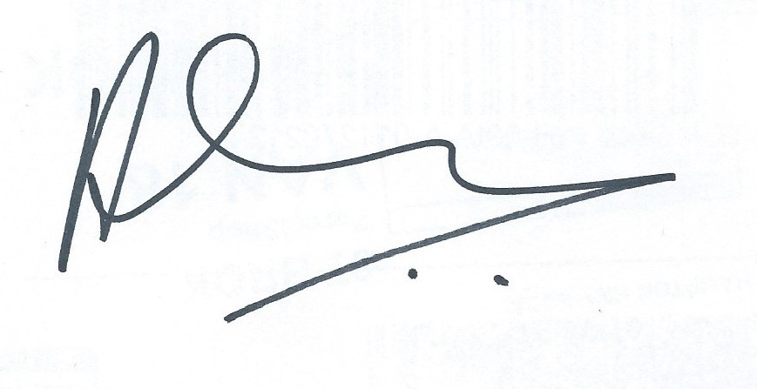
A
Minutes of the meeting of the council
Held on 29th January 2024
Present – Cllr Skinner (chair), Cllr Ellis, Cllr Hempsall, Cllr Mason. Also 2 members of the public

01/24 | Apologies received from Cllr Watkins
02/24 | No declarations of interest were made
03/24 | The minutes of the meeting held on 6th November 2023 were resolved to be a true record, proposed Cllr Hemsall seconded Cllr Ellis passed unanimously.
04/24 | Public participation – with the agreement of the chair Tessa Draper (member of public) gave a short presentation on climate resilience and community climate action. This included discussion around training that will be made available to councillors and others around the impact of climate change on food security, air quality, flood resilience and open spaces. This will be further discussed as an agenda item in the meeting scheduled for March 11th.  The impact of the recent storms and fly tipping were also discussed
05/24 | Defibrillator funding – the clerk will approach Fairfax & Favor for a donation, Cllr Skinner will contact Natures Menu.  Racetrack noise – the expected follow-up meeting has not yet taken place.  North end – residents are encouraged to make their views on this, and other local plan issues known via ‘common place’. Cllr Skinner will contact BDC for clarification on what support they are able to give the council on traffic calming measures.  The council is seeking a meeting with Cllr Suggitt and planning officers.
06/24 | Live streaming of meetings – this was deferred until next meeting
07/24 | Free library – Cllr Mason offered to contact Travis Perkins for their support.
08/24 | Planning – all items were ratified proposed Cllr Skinner seconded Cllr Hempsall (unanimous)
09/24 | Precept – a precept request of £6,000 was agreed for 2024-25 proposed Cllr skinner seconded Cllr Hempsall (unanimous)
10/24 | Finance – items listed on the agenda were agreed proposed Cllr Skinner seconded Cllr Ellis (unanimous)
11/24 | Hedgehogs – it was agreed to purchase 2 signs at a cost of £53.98 in order to monitor their effectiveness, sites will be explored and reported.
12/24 | The environmental protection officer will be contacted regarding light nuisance and the fulfilment of planning restrictions
13/24 | The next meeting of the council will be on 11th March

Signed by Cllr Skinner
Chair of the council

B

Breckland Council are seeking your views on their draft Local Validation List (LVL), available to view via at https://www.breckland.gov.uk/planning/local-validation-list. Responses to the consultation must be submitted to the Council by email to planning@breckland.gov.uk (please title your email ‘Local Validation List consultation response’), or you can write to the Council at Planning, Elizabeth House, Walpole Loke, Dereham, Norfolk, NR19 1EE.

