SUMMONS TO COUNCILLORS, INVITATION TO OTHER INTERESTED PERSONS TO ATTEND
Notice is hereby given that a meeting of the Parish Council is to be held on
at 6.30pm on Monday 29th January 2024 at racetrack hospitality suite.
AGENDA
supporting
paper
1 | Chairperson open the meeting, and ask if anyone wishes to record the meeting, and if so to remind those present of the appropriate guidelines
2 | Apologies for absences
3 | Declarations of interest
4* | To resolve that the minutes of the Council meeting held on 6th November 2023 are a correct record | A
5 | Public participation – members of the public are invited to make representations, ask questions, or give evidence to the meeting in respect of items on the agenda. In accordance with standing order 3 (parts 5-7) this item shall be limited to 20 minutes unless directed by the chair of the meeting.
6 | Reports from county Councillor
7 | Reports from District Councillors
8 | To receive updates on matters from previous meetings including but not limited to  Defibrillator funding  Race track noise evaluation meeting  Land at North end
9 | To discuss live steaming and recording of parish council meetings  In order to improve security and facilitate the storage of documents, the council has now purchased a laptop for use by the clerk. A secondary benefit of this purchase is the potential to record and stream meetings.
10 | To discuss the installation of a ‘free library’ in the bus stop at North end.  Free libraries are becoming increasingly popular, essentially, they are a free to use book exchange, usually sited in an unlocked cabinet and available for community use.
11 | Planning applications – to report on and consider applications etc. as advised by Breckland District Council  Note - the council is no longer able to comment on items in italics due to date restrictions. No further applications have been recieved at the time of the production of this agenda  3PL/2023/1213/A illuminated signs at Snetterton park  3PL/2023/0752/D variation of conditions JMDL Snetterton park  3PL/2023/1185/A illuminated signs Richard Johnston ltd Harling Road  3PL/2023/1184/A as above  3PL/2023/1168/HOU alterations to house and outbuildings Hole in the wall house South end  3PL/2023/0794/F retrospective change of use The old barn  3PL/2023/1092/VAR deer gates World horse sanctuary
12 | To oversee the proposed budget for the year 2024-2025, review and agree the precept requirement for 2024-2025 | B
13 | Page 1 of 2  Finance –  Financial report at end of December 2023  Cashbook balance £ 3,503.49  ICO (information commissioners office) £35.00 D/D  Clerk salary November & December £348.08  Purchase of laptop computer (reimbursement*) £149.00 inc VAT  HMRC £86.80  DM payroll services £60.00 (October to March)  New balance carried forward £2,825.41  *as by the directed of the council, the purchase of the laptop was initially undertaken by Cllr Hepmsall who will be reimbursed.
14 | To discuss the purchase and potential location of hedgehog awareness signs | C
15 | To discuss light pollution policy | D
16 | Meeting dates 2024. The council usually meets every 2nd month although special meetings may occasionally be called. Due to restrictions regarding the availability of a venue it is not possible to publish a list of dates for the year.
 | To note next meeting date in March to be confirmed
Tony Holden (clerk) 09/01/2024 31, Ashleigh Gardens, Wymondham NR18 0EX
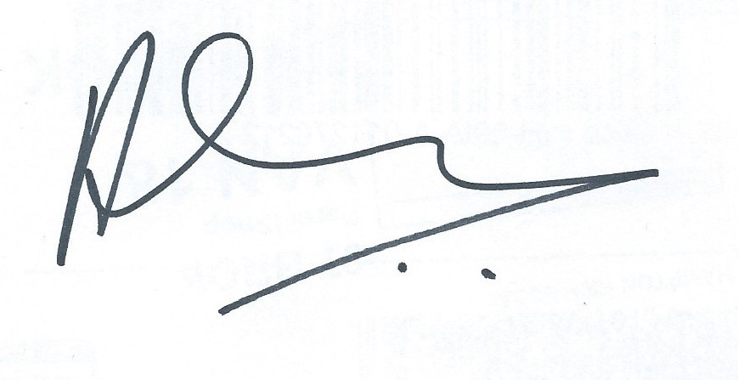

Page 2 of 2

