SASNETTERTON PARISH COUNCIL
SUMMONS TO COUNCILLORS, INVITATION TO OTHER INTERESTED PERSONS TO ATTEND
Notice is hereby given that a meeting of the Parish Council is to be held on
23rd January 2023 at 6.30pm at Tyrells Restaurant
AGENDA
 | Chairperson open the meeting, and ask if anyone wishes to record the meeting, and if so to remind those present of the appropriate guidelines | Attached  paper
1 | Apologies for absences
2* | Declarations of interest
3* | To resolve that the minutes of the Council meeting held on 14th November 2022 are a correct record | A
4 | Public participation – members of the public are invited to make representations, ask questions, or give evidence to the meeting in respect of items on the agenda. In accordance with standing order 3 (parts 5-7) this item shall be limited to 20 minutes unless directed by the chair of the meeting.
5 | To receive updates on matters from previous meeting including but not limited to  - Highways including verge cutting JR  - World horse welfare liaison MW  - Amenity land LG
6 | Breckland Local Plan Update – action and timescales | F
7* | Website transition | B
8 | Notice boards and alternative methods of communication
9 | To review strategic list, and decide further items for inclusion | C
10 | To review parish action plan, and decide items for inclusion | D
11 | County broadband
12 | Defibrillator site and funding | E
13* | Planning applications – to consider applications as advised by Breckland DC including  3PL/2022/1422/F  3PL/2022/1245/F
14* | Finance –  Clerk salary Oct,Nov,Dec. £505.28  Stationary £49.99
15 | Reports from county Councillor
16 | Reports from District Councillors
17 | To receive items for next agenda
18 | To note next meeting date
Tony Holden (clerk) 8th January 2023 31, Ashleigh Gardens, Wymondham NR18 0EX

SNETTERTON PARISH COUNCIL
A
MINUTES OF THE MEETING OF THE COUNCIL
HELD ON 14th November 2022 at Tyrells restaurant
Present Cllr Goldsmith (chair), Cllr Walsh, Cllr Skinner Cllr Suggitt 15 members of the public.
Page 1 of 2
70/22 | Apologies for absence – Cllr Askew, Cllr Romero
71/22 | Declarations of interest – none
72/22 | It was resolved to approve the minutes of the annual meeting of the council held on 3rd October 2022 were a correct record. Proposed Cllr Skinner seconded Cllr Goldsmith
73/22 | Public participation – Breckland local plan update, call for sites. Submitted sites was discussed at length with the following points being raised.  - It was felt that residents should have been made aware of the call for sites, Cllr Suggitt explained that this is the first stage in the process and submitted sites had not yet been considered by planners. She also said that landowners on the district councils list had been emailed directly, and that the parish council was notified. Residents were directed to the ‘commonplace’ website, where they can find up to date information.  - Enterprise zones, Cllr Suggitt explained that following government changes this initiative was currently on hold.  - It was explained that consultation would commence when and if sites were approved by Breckland district council (BDC)  - Cllr Walsh read an email that has been sent to BDC raising issues such as the detrimental effects of further development on local ecology and wildlife, the question of lack of benefit to the village from commercial development was also raised and the clerk was instructed to contact the MP and chief executive of BDC to seek their support in halting further development that is to the detriment of residents.  - Queries were raised over the ownership of the land being submitted. This was clarified at the meeting, Wyatt, Stammers and the WHW.  - As some land is owned by World Horse Welfare (WHW) Cllr Walsh agreed to forward relevant sections of the email (mentioned in d above) to members of tha public who requested it  - The policy of building on green fields and it’s impact on food security was raised
74/22 | Updates on matters from previous meetings –  - Feed mill confirmed that they expected work to begin shortly, however the current instabilities in the economy may result in delays  - Cllr Goldsmith reported that there is a new manager at the track, and 5 noise complaints had been received between February and August 2022. Residents that are experiencing excessive noise were advised to contact the environment team at BDC  - Cllr Suggitt suggested that the council produce a “high level strategic list of requirements” to be sent to the director of planning at BDC.  - No site for a defibrillator has been identified Cllr Walsh will ask (WHW) if they can provide one.
75/22 | BDC call for sites – no further discussion took place as it was felt that all points had been addressed in public speaking (see 73/22 above)
76/22 | Recycling as no appropriate site can be identified in the residential area Cllr Goldsmith will ask on the industrial area
77/22 | Action plan – it was agreed that in order to keep track of council projects an action plan outlining progress and responsibilities will be included in future agendas
78/22 | The council agreed to move to the Norfolk associations of local council (NALC) template, a letter of appreciation is to be sent to the current developer. Proposed Cllr Goldsmith seconded Cllr Skinner
SNETTERTON PARISH COUNCIL
MINUTES OF THE MEETING OF THE COUNCIL
HELD ON 14th November 2022 at Tyrells restaurant
Present Cllr Goldsmith (chair), Cllr Walsh, Cllr Skinner Cllr Suggitt 15 members of the public.
Page 2 of 2

79/22 | Cllr Walsh reported that the missing footbridge over the river Thet makes the footpath unusable. This will be added to the strategic list (see 74/22 b above)
80/22 | A precept of £4,500 was agreed for the year 2023-2024 proposed Cllr Skinner seconded Cllr Goldsmith
 | Page 2 of 2
81/22 | It was agreed to authorise delegated authority to the clerk to respond to planning applications on behalf of the council if required. Proposed Cllr Skinner seconded Cllr Goldsmith
82/22 | No planning applications were discussed
83/22 | No report from county councillor
84/22 | Cllr Suggitt explained the impact of nutrient neutrality and its implications for development and the local economy
85/22 | The next meeting is scheduled for January 23rd 2023
The meeting closed at 8.12pm Signed L Goldsmith (chair)

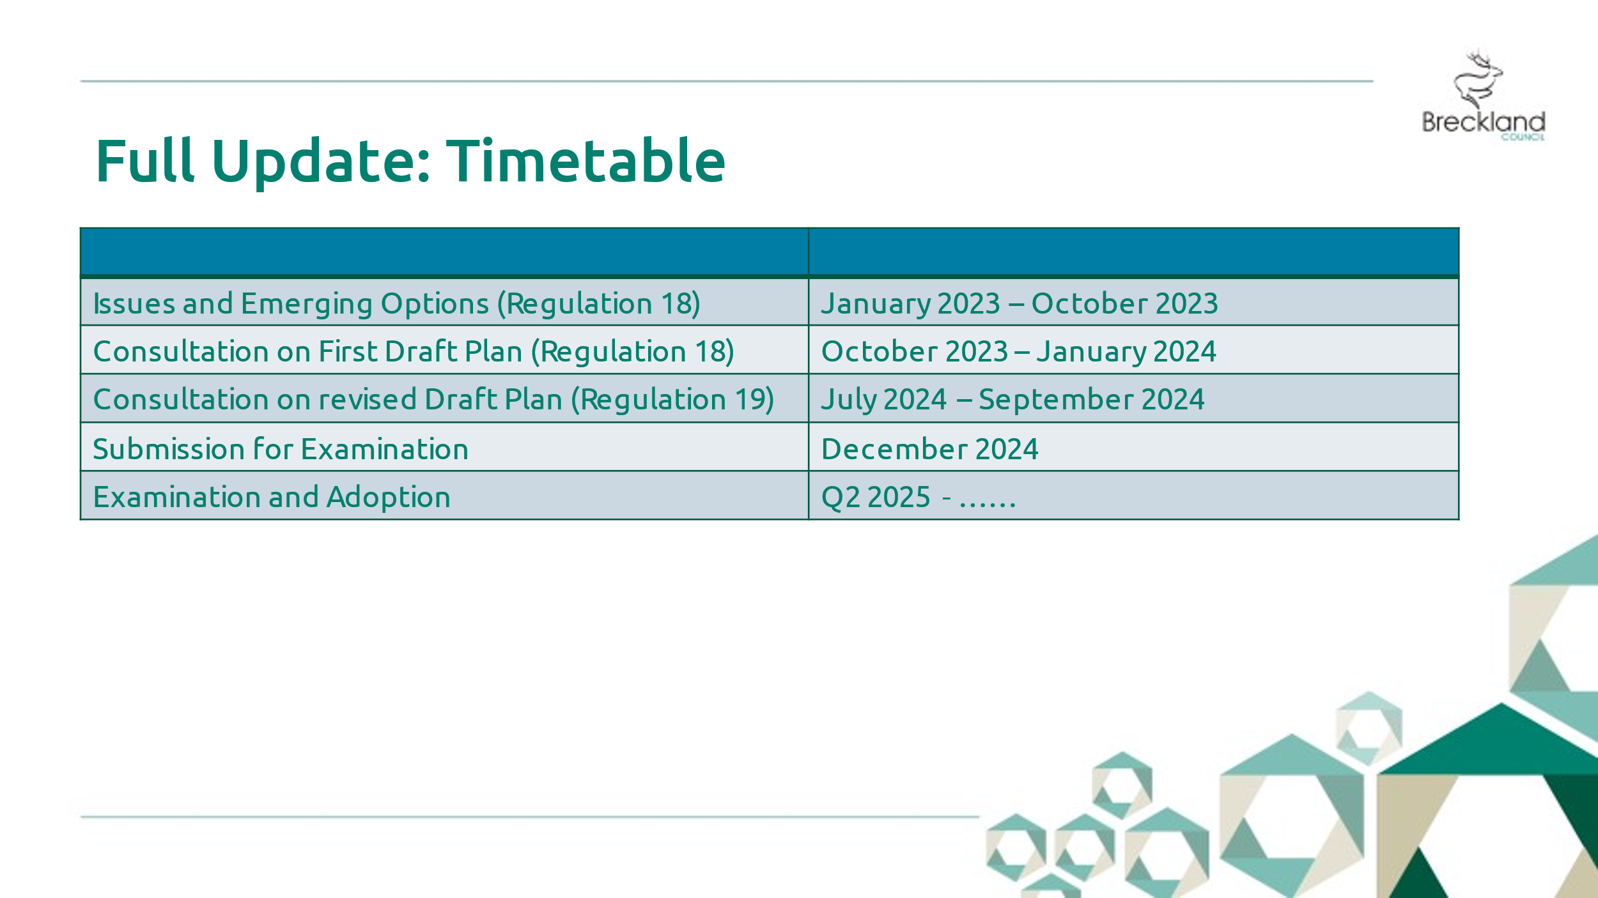
B

Website upgrade
C

Snetterton has the following options:

1. Stop using https://www.snettertonparishcouncil.com/ and use https://snetterton.norfolkparishes.gov.uk/ instead. If this option is selected perhaps you could post a message on the old site giving a link to the new one for a short period? Or better perform a 301 permanent redirect so people are diverted to the new site?

2. Retain https://www.snettertonparishcouncil.com/. The domain will need to be transferred to the councils own account as you suggest, and the council would need to be comfortable editing DNS records for this etc. We can give general guidance but not specific advice. We can then redirect the old domain name to the new site, however to do this requires an additional SSL secure certificate that will come at an additional cost to the council.
The additional cost for option 2 is £75 per year.

Current advice is that Parish Councils should use gov.uk domain names so I suggest we take option 1 unless the council specifically wants to retain the current domain.

SNETTERTON PARISH COUNCIL
D
List of requirements

- Broadband. The current broadband availability in the village is poor and needs to be updated.
- Footpaths. The bridge over the river Thet is in need of either repair or replacement.
- Cycle paths. Due largely to the ongoing commercial development around the A11, the roads through the village are becoming busier and can be hazardous to cyclists and walkers.
- Amenity land. The village currently does not have any amenity land available for community use, however a small parcel of unused land has been identified at North End. This is owned by BDC and is partially leased for agriculture.

Snetterton Parish Council Action Plan
E

 | Objective | Action | Responsibility | By When
1. | Influence the timing and frequency of the verge cutting throughout the village to better benefit wildlife, flora and forna. | Contact……. | Cllr Romero | Spring 2023
2 | Establish funding source for defibrillator | BDC and others | clerk | March ‘23
3 | Recruit and create speed watch program | Police (when sufficient people are committed)
4 | Obtain amenity land from BDC, either gifted or long term leased | Added to strategic list

F
Defibrillator site and funding

- World horse welfare, have kindly offered to have a defibrillator sited on the wall adjacent to their entrance, they will also provide a power supply.
- The government recently announced an initiative to match fund defibrillators.
- AED donate offer a package that includes cabinet, supply and installation of unit ongoing training and 8 year warranty at a cost of £2099 less £400 discount (£1699) this seems to be mid range market price
- BDC have been contacted re possible funding – awaiting reply

Press release

Number of defibrillators to be increased with new funding
The number of life-saving defibrillators will be increased with new funding announced today by at least 1,000.
From:
Department of Health and Social Care, Helen Whately MP, and The Rt Hon Steve Barclay MP
Published
29 December 2022
- £1 million fund will increase defibrillators in the community by an estimated 1,000
- Organisations will be invited to bid to place defibrillators in areas most in need
- Successful bidders will be asked to match funding, potentially doubling the number of new defibrillators
The public will have faster access to life-saving defibrillators as the government announces a new £1 million fund to increase the number of automated external defibrillators (AEDs) in communities most in need - providing an estimated 1,000 new defibrillators in community spaces across England.
The Department of Health and Social Care will invest the funding through an independent partner in the new year who will manage grant applications from bidding organisations. Those selected will be asked to match the funding they receive fully or partially, potentially doubling the number of new defibrillators created by the fund.
Applicants will also be asked to demonstrate that defibrillators will be placed in areas where they are most needed, such as places with high footfall, vulnerable people, rural areas, or due to the nature of activity at the site.
Examples could include town halls, community centres, local shops, post offices and local parks, to ensure that defibrillators are evenly spread throughout communities and easily accessible if someone is experiencing an unexpected cardiac arrest.
The independent partner managing the fund will be announced in due course and will work with the Department of Health and Social Care to ensure that new defibrillators in the community are accessible on a 24/7 basis and are equally accessible across England to all social groups.

