**SNETTERTON PARISH COUNCIL**

SUMMONS TO COUNCILLORS, INVITATION TO OTHER INTERESTED PERSONS TO ATTEND

Notice is hereby given that a meeting of the Parish Council is to be held on

14th November at 6.30pm at **Tyrells Restaurant**

**AGENDA**

|  |  |  |
| --- | --- | --- |
|  | Chairperson open the meeting, and ask if anyone wishes to record the meeting, and if so to remind those present of the appropriate guidelines | Attached  paper |
| 1 | Apologies for absences |  |
| 2 | Declarations of interest |  |
| 3 | To resolve that the minutes of the Council meeting held on 3rd October are a correct record | A |
| 4 | Public participation – members of the public are invited to make representations, ask questions, or give evidence to the meeting in respect of items on the agenda. In accordance with standing order 3 (parts 5-7) this item shall be limited to 20 minutes unless directed by the chair of the meeting. |  |
| 5 | To receive updates on matters from previous meeting including but not limited to -   1. MSV liaison meeting **LS** 2. Wish list 3. Highways including verge cutting 4. World horse welfare liaison MW 5. Defibrillator siting possibilities 6. Amenity land **MW** |  |
| 6 | Breckland Local Plan Update - Call for Sites 2022:  Submitted Sites  a. Snetterton Circuit  b. Land off Falcon Road  c. Land at Heath Road |  |
| 7 | Recycling as a funding opportunity **MW** |  |
| 8 | Parish action plan **MW** | B |
| 9 | To review the council’s website update and consider submission from current provider and Norfolk ALC | C |
| 10 | Public Footpaths |  |
| 11 | Budget and precept – to review the draft budget and decide the parish precept for 2023-2024 | D |
| 12 | Planning – to allow delegated authority to comment on planning applications and amend standing orders appropriately | E |
| 13 | Planning applications – to consider applications as advised by Breckland DC |  |
| 14 | Reports from county Councillor |  |
| 15 | Reports from District Councillors |  |
| 16 | To receive items for next agenda |  |
| 17 | To note next meeting date |  |
|  |  |  |

*Tony Holden (clerk) 6th November 2022 31, Ashleigh Gardens, Wymondham NR18 0EX*

**SNETTERTON PARISH COUNCIL**

A

DRAFT

MINUTES OF THE MEETING OF THE COUNCIL HELD ON 3rd October 2022

at Tyrells restaurant

Present Cllr Goldsmith (chair), Cllr Walsh, Cllr Skinner no members of the public.

|  |  |
| --- | --- |
| 57/22 | Apologies for absence – Cllr Suggitt, Cllr Romero |
| 58/22 | Declarations of interest – none |
| 59/22 | It was resolved to approve the minutes of the annual meeting of the council held on 3rd October 2022 were a correct record. Proposed Cllr Goldsmith seconded Cllr Skinner |
| 60/22 | Updates on matters from previous meetings –   1. Highways – It was reported that although some work had been carried out this was of a poor quality. Cllr Skinner will contact Cllr Askew to raise the issue 2. Verge cutting – It was agreed that the current verge cutting service is inadequate and is in need of review. This will be monitored and referred for future discussion 3. Amenity land – Cllr Goldsmith reported that Breckland DC had visited the area in North End that the council would like to take over as amenity land. The council resolved to oppose any building on this plot. 4. Speed watch – this project has been put on hold until sufficient volunteers can be found. Cllr Askew will be asked to provide results of the traffic count and to confirm that a speed restriction through the village is still on his agenda. 5. Business liaison group - Cllr Suggitt submitted a written report stating that this is not something that the district council would normally be involved in. |
| 61/22 | Wish list – a village centre sign is to be added to the list which currently includes -   1. 4 x village entry signs 2. Defibrillator 3. SAM 2 speed camera 4. Bus shelter maintenance inc. planting of bulbs etc 5. Please dive slowly through the village signs   Cllr Suggitt and Cllr Askew are to be contacted regarding ways of asking developers to contribute to these projects. Re (d) above a Facebook call for quotes is to be initiated. |
| 62/22 | Planning – no objections were raised in regard to 3PL/2022/1088/F, or 3PL/2022/1092/F  The council expressed concern over the apparent deviation of permission granted under 3PL/2021/0859/HOU in that a large soil bund and structure have been added to this development, without consent. Breckland DC enforcement will be informed and requested to take action |
| 63/22 | Hedgehog highways were discussed, it was considered unnecessary to purchase this equipment in a rural village with relatively few solid fences. |
| 64/22 | The council noted that the response to the Breckland DC partial review had been submitted |
| 65/22 | Cllr Walsh, will contact World Horse Welfare to initiate a meeting in order to encourage working together for the benefit of the village |
| 66/22 | Cllr Walsh will submit a template for a parish council action plan for future discussion |
| 67/22 | Finance – the following payments were authorised   1. DM payroll services April 2022-March 2023 £60 2. ICO (data protection officer) £35 3. A. Holden – clerk (salary June, July, August & September) £751.36   A ‘snapshot’ review of the budget was noted |
| 68/22 | Cllr recruitment – it was noted that people working in the village are eligible to apply to become a Councillor |
| 69/22 | Next meeting – **The next scheduled meeting will be on Monday November 14th** |

The meeting closed at 7.37pm

B

**Snetterton Parish Council Action Plan template**

|  |  |  |  |  |
| --- | --- | --- | --- | --- |
|  | **Objective** | **Action** | **Responsibility** | **By When** |
| 1. | Influence the timing and frequency of the verge cutting throughout the village to better benefit wildlife, flora and forna. | Contact……. | Cllr Romero | Spring 2023 |
|  |  |  |  |  |
|  |  |  |  |  |
|  |  |  |  |  |

Email recieved from Kevin Bacon of Norfolk ALC 29th Sept

C

Hi Tony,

 As discussed on the phone here are your website options through Norfolk ALC, all pricing is on top of your existing subscription and is only available to Norfolk ALC members.

 We currently charge £35 per year for website hosting and a norfolkparishes.gov.uk domain name (eg snetterton.norfolkparishes.gov.uk). For this you get the basic website setup with some basic pages eg Agendas / Minutes etc and a 45-60 one to one online training session to teach you how to manage it and add further content yourself. If you wish to keep the content on your existing website you’d need to copy that over yourself.

 We also offer an optional managed content service where we upload your website content for you, which can be a good time saver for you, this is charged at an additional £110 per year. If you take this option we can copy all of your existing content from your existing website to the new one for you (assuming it is still online at the time you go ahead).

 These charges are however due to be reviewed for next year, as they have been kept at this low rate for many years now, so will increase come renewals - though we will aim to remain the cheapest option for Parish Council websites.

As we host approximately 190 parish council websites we do restrict what can be done with them, this generally means you don’t have as much control over the visuals of your site compared to stand alone options. You can change logos and colours etc but they will all have a similar look and feel, such as:

<https://shrophamparishcouncil.norfolkparishes.gov.uk/>

<https://walpolepc.norfolkparishes.gov.uk/>

<https://hethersett-parish-council.norfolkparishes.gov.uk/>

<https://denverparishcouncil.norfolkparishes.gov.uk/>

We are looking to upgrade the system to make the sites look a little more modern and hope to have this completed by the end of the year.

 We maintain the software at our end and look after security etc so there are no other charges, software upgrades etc are all included in the annual fee.

The alternative proposal (see below) has been received from the current developer at a cost of £320 for an upgrade to the existing site, plus £76 per year hosting.



*Document title:*

Website updates 2022

*Prepared for:*

Snetterton Parish Council

*Date:*

04/10/2022

*Outline*

This document outlines proposed development changes to the current snettertonparishcouncil.com website and the reasons for making the changes. This includes time estimates for each task and their associated costs should you decide to proceed.

*Software Update*

*SilverStripe upgrade*

The current parish council website is running on the SilverStripe content management system, the website is running on version 3 of the CMS, so I propose we upgrade the website to the new version.

Following a successful upgrade of the website to the latest version of SilverStripe, I will provide a training session to take you through the process of editing content via the CMS - the experience of adding/editing pages and meeting notes will be similar but a training session will make you aware of all the latest features of the CMS.

**Security**

SilverStripe 3 stopped receiving security patches in Q4 2021, meaning that the website could be vulnerable to attacks from malicious users. Additionally, the website is built using the PHP programming language, SilverStripe 3 is only compatible with PHP 7.4, this will be retired in November 2022 meaning the underlying language which runs the website will also be vulnerable.

**New features**

There are a number of new features in SilverStripe 4 which we can take advantage of after upgrading, these include:

* New and improved text editor - making it easier for you to create on-page content
* Improved document management system - making it easier to manage the documents you’ve uploaded to the CMS
* Responsive interface - the SilverStripe interface will adapt to any screen size

*Front-end improvements*

Improvements to the front-end of the website cover anything that the user can see when they visit the website, I’ve identiﬁed various improvements we can make to the website which will beneﬁt users by either;

1. ﬁxing elements which are broken/hard to use
2. improving the site accessibility, this is important for users who may be visually impaired or have another disability which prevents them from having full use of the website

*Navigation improvements*

These are screenshots of the website navigation:



The navigation wasn’t originally designed to hold long titles such as these. The navigation style will be updated to be more ﬂexible and allow for longer titles, additionally, we will work together to determine which pages should be prioritised in the navigation and improve the structure to make it easier for users to ﬁnd the key pages on the website.

Designs for the new navigation will be provided in advance of the development changes taking place.

*Improved meeting interface*

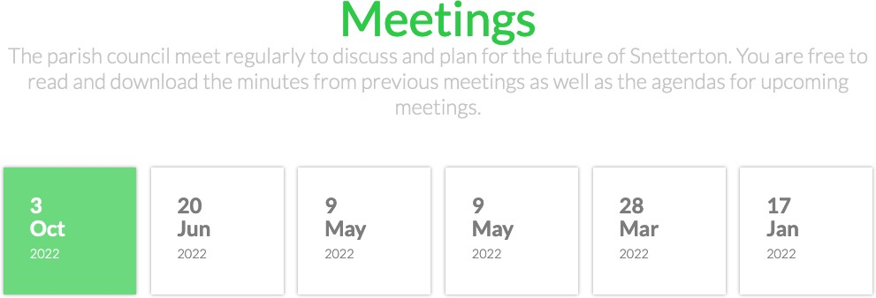

The current meeting interface isn’t user-friendly and it obscures important information (like the meeting time and location), designs will be provided for an improved interface.

*Accessibility improvements*

The following improvements will ensure that the website is usable for people with visual impairments and other disabilities.

**Colour contrast**

In order for users with visual impairments to use the site the colour contrast of the text needs to be improved, the current green colour doesn’t pass accessibility standards, I propose we switch to a darker green which will give more contrast between the text and background.

Additionally, the light grey colour is too light to be on a white background.

**Colour contrast - hero image**

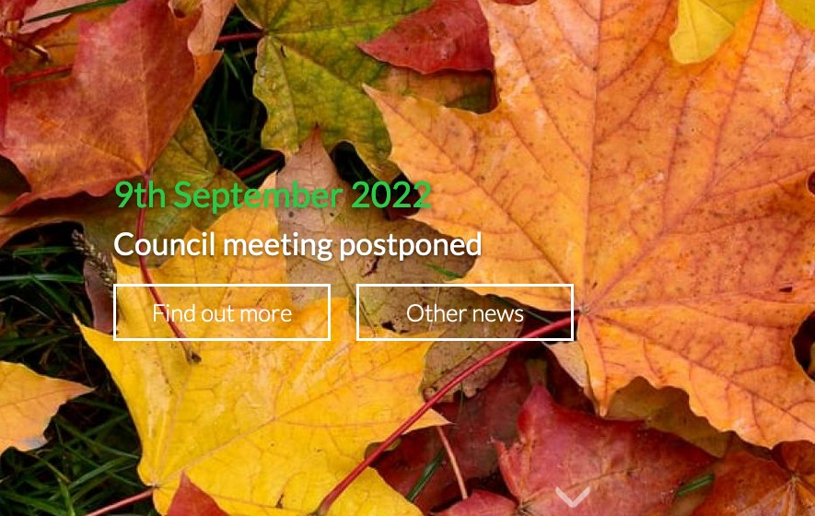

The combination of white text on a light background image with complex patterns makes it hard to read, as discussed we can add the option to have a dark overlay over the background image which will improve text readability.

**Keyboard navigation**

In order for users who cannot use a mouse to navigate through the website we should add improvements which make it possible to select elements with the keyboard.

*Contact form*

As discussed we will remove the current contact form in favour of a link to email the parish council directly to improve the experience of councillors receiving enquiries from members of the public.

*Legal compliance*

*GDPR/Privacy policy (TBC)*

The website may require a compliant privacy policy, we do not store cookies and removing the contact form will mean we are no longer storing user data on the website but Snetterton Parish Council should seek guidance on this point.

*Domain transfer*

As discussed the parish council should own the domain name `snettertonparishcouncil.com` rather than me (Andrew Haine) retaining ownership. The process of this will be:

* 1. Snetterton Parish Council should set up an account with namecheap.com using the Parish Council’s Google Mail account. (<https://bit.ly/3fvLqAH>*)
  2. Andrew Haine will then initiate the transfer of the domain
  3. Snetterton Parish Council will accept the transfer
  4. Snetterton Parish Council will now own the domain and pay Namecheap directly for ownership on an annual basis (This cost will be removed from my annual invoice)
  5. Andrew Haine to conﬁrm nameservers are pointed to Cloudﬂare
     + **jobs.ns.cloudﬂare.com**
     + **meera.ns.cloudﬂare.com**

* Namecheap afﬁliate link

*Cost estimates*

These estimates are valid for 30 days from the date of this document, my hourly rate is usually

£40/hr but I’m happy to reduce this to £20/hr for the parish council due to budget restrictions.

|  |  |  |
| --- | --- | --- |
| **Task** | **Time estimate (hrs)** | **Cost (£)** |
| **SilverStripe 4 upgrade** | **8** | **£160.00** |
| **Front-end improvements: Navigation changes** | **2.5** | **£50.00** |
| **Front-end improvements: Meeting interface** | **2** | **£40.00** |
| **Front-end improvements: Accessibility** | **2.5** | **£50.00** |
| **Front-end improvements: Contact form replacement** | **1** | **£20.00** |
| **Total** | | **£320.00** |

*Document versions*

|  |  |
| --- | --- |
| **Version** | **Date** |
| **1** | **04/10/2022** |

D

**Snetterton Parish Council - 2023/2024 Budget 1st DRAFT**

|  |  |  |  |  |  |  |
| --- | --- | --- | --- | --- | --- | --- |
| **Snetterton Parish Council - 2023/2024 Budget 1st DRAFT** | | | | | |  |
|  | **2022/23 original Budget** | **2022/23 to date** | **Predicted for rest of year** | **2022/23 Total** | **DRAFT 2023/24 Budget** | **Notes** |
| **Opening Balance** | **3,413** |  |  |  | **3,403** | Includes both bank accounts |
|  |  |  |  |  |  |  |
| **Receipts** |  |  |  |  |  |  |
| Precept | **3,605** |  |  | **3,605** | **5,000\*** | *Subject to agreement |
| Grants | **0** | 0 | 0 | **0** | **0** |  |
| Interest | **0** | 0 | 0 | **0** | **0** | As yet no interest |
| VAT Refund | **16** | 0 | 16 | **0** | **0** | VAT paid in one year is recovered the next. |
| Other | **6** | 0 | 0 | **0** | **0** | Wayleave payment |
| **TOTAL receipts** | **3627** |  |  | **3,605** | **5,000\*** | *Subject to agreement |
|  |  |  |  |  |  |  |
| **Payments** |  |  |  |  |  |  |
| Clerk's Salary + use of home as office & associated costs | **2,493** | 1,406 | 1,200 | **2,606** | **2,700** | Includes NJC agreed increase |
| Clerk's Mileage Allowance | **200** | 56 | 70 | **126** | **130** |  |
| Training costs | **100** | 30 | 60 | **90** | **150** | Assumes 2 new Councillors & ongoing training as required |
| Insurance | **400** | 356 | 0 | **356** | **400** | Policy needs renewing |
| Subscriptions | **175** | 35 | 138 | **173** | **180** | Information Commissioner (£35), Norfolk ALC (£95), SLCC (£43) + inflation |
| Grass cutting |  |  | 0 | **0** | **0** | Now done by Breckland Council |
|  |  |  |  |  |  |  |
| Section 137 |  |  |  | **0** | **50** | Section 137 of the Local Government Act 1972 enables local councils to spend a limited amount of money on purposes for which they have no specific statutory expenditure |
| Hire of Venue | **0** | 0 | 0 | **0** | **0** | assuming use of Tyrrels |
| Publications | **0** | 0 | 0 | **0** | **170** | Arnold Baker – local government administration |
| Audit & Election costs | **80** | 85 | 0 | **85** | **90** | Internal Audit – assumes exemption from external audit |
| Postage & Telephones | **20** | 0 | 20 | **20** | **20** |  |
| Stationery | **150** | 18 | 60 | **78** | **100** | Ink prices are increasing. |
| VAT | **30** | 6 |  | **6** | **6** | To be recovered in 2023/24 |
| Website | **75** | 0 | 350 | **350** | **150** | Dependant on decision to use NALC. |
| Other | **0** | 0 | 0 | **0** | **0** |  |
| Contingency | **500** | 0 | 0 | **0** | **500** | . |
| Election reserve for 2023 | **125** | 0 | 125 | **125** | **325** | Breckland has yet to confirm the cost of the election in May 2023. As a guide the parish element could be between £75 & £750 dependant on whether it is contested. However, when the district is included, the total could be in the region of £1300. This is usually shared between District and Parish, so £650 for the parish, say £700 to allow for inflation by 2023. A reserve has been set aside of £125 per year for 3 years (£375) . |
| **TOTAL** | **4,348** | **1,992** | **2,023** | **4,015** | **4,971** |  |
|  |  |  |  |  |  |  |

Summary

It is anticipated that current year will see the council facing an overspend of the original budget that will necessitate the use £233 from reserves. This is due to the website needing an overhaul to bring it up to date and compliant with current regulations.

Below is a table of the impact of an increase in precept on a band D property

All figures are per annum in £

|  |  |  |
| --- | --- | --- |
| Precept | Band D per annum | Per week |
| 3,605 (current) | 43.02 | 0.83 |
| 3,800 | 45.35 | 0.87 |
| 4,000 | 47.73 | 0.92 |
| 4,200 | 50.12 | 0.96 |
| 4,500 | 53.70 | 1.03 |
| 4,750 | 56.68 | 1.09 |
| 5,000 | 59.67 | 1.15 |
| 5,250 | 62.65 | 1.20 |

All band rates at proposed precept of £5,000

|  |  |
| --- | --- |
| Band A | £39.78 |
| Band B | £46.41 |
| Band C | £53.04 |
| Band D | £59.67 |
| Band E | £72.92 |
| Band F | £86.18 |
| Band G | £99.44 |
| Band H | £119.33 |

All band rates at precept of £4,500

|  |  |
| --- | --- |
| Band A | £35.80 |
| Band B | £41.77 |
| Band C | £47.73 |
| Band D | £53.70 |
| Band E | £65.63 |
| Band F | £77.57 |
| Band G | £89.50 |
| Band H | £107.40 |

E

Planning applications are received from Breckland District Council at intervals that do not always allow the council to meet and consider a response, it is therefore recommended that the clerk is given delegated authority to reply on behalf of the council, and that this authority is written into standing orders.

Delegated authority to comment on planning applications,

The clerk is hereby authorised to respond to planning applications on behalf of the council after contacting all Councillors via email if the following circumstances apply.

1. The application reply is required before the next scheduled meeting of the council
2. An extension to enable comments has been requested, and denied

Having received the views of Councillors the clerk will take these into account when replying to Breckland District Council.

In the event of conflicting views being expressed by Councillors, a special meeting will be called to reach a majority view.

Any decisions or actions taken under this delegated authority are to be ratified at the next public meeting.

